Portland Urban Development
Quantifying and Visualizing Urban Heat with Compounding Vulnerabilities to Support Community Depaving Initiatives

Technical Report
August 11th, 2023

Keegan Kessler (Project Lead)
Hadwynne Gross
Jordan Larson
Adam Nayak

Advisors:
Dr. David Hondula (Arizona State University)
Lance Watkins (Arizona State University)
Joe Gordon (Oregon Metro, Portland Community College)
Joshua Applegate (Oregon State University)
Lauren Childs-Gleason (NASA Langley Research Center)
Dr. Kenton Ross (NASA Langley Research Center)
Dr. Vivek Shandas (Portland State University)

Fellow:
Julianne Liu (Virtual Environmental Justice)

1. Abstract
Urban heat is a pressing concern in Portland, Oregon as climate change induced heat waves increase. Cities experience higher temperatures due to the urban heat island effect (UHI), and environmental injustice and disenfranchisement in minority communities expose low-income and Black, Indigenous, and People of Color (BIPOC) residents to more extreme and debilitating heat events. Our team identified Portland’s communities on the frontlines of urban heat impacts by overlapping environmental and social vulnerabilities using NASA Earth observations. We partnered with Depave, a Portland-based nonprofit that works alongside communities to replace pavement with greenspace in historically disenfranchised areas. Using Landsat 8 Thermal Infrared Sensor (TIRS) imagery, we mapped Land Surface Temperature (LST) and developed a heat-specific Social Vulnerability Index (SVI) through a Principal Component Analysis (PCA) to identify Portland’s communities with the highest potential heat vulnerability. Then, we calculated the temperature change of depaving in six case studies to quantify Depave's efforts in heat mitigation and environmental justice. Our analysis demonstrated that, throughout Portland, there are frontline communities experiencing high potential social vulnerability to extreme temperatures due to environmental injustices and over-pavement. Finally, Depave’s impact on urban heat is observable and quantifiable using remote-sensing data and tools, with an average of 1ºF LST decrease across the six case studies. We illustrated the significance of local urban heat mitigation efforts and propose next steps for conducting inclusive and intentional research that highlights the lived experiences and resilience of frontline communities.

Key Terms
Environmental justice, frontline communities, remote sensing, Landsat 8 TIRS, urban heat island (UHI), land surface temperature (LST), social vulnerability index (SVI), principal component analysis (PCA)

2. Introduction
2.1 Background Information
Portland, Oregon is home to roughly 635,000 residents (US Census Bureau, 2023) and is located in the Pacific Northwest (Figure 1). The city is characterized by heavy precipitation, but communities have had growing concerns regarding climate change-induced heat waves and higher temperatures in recent years.

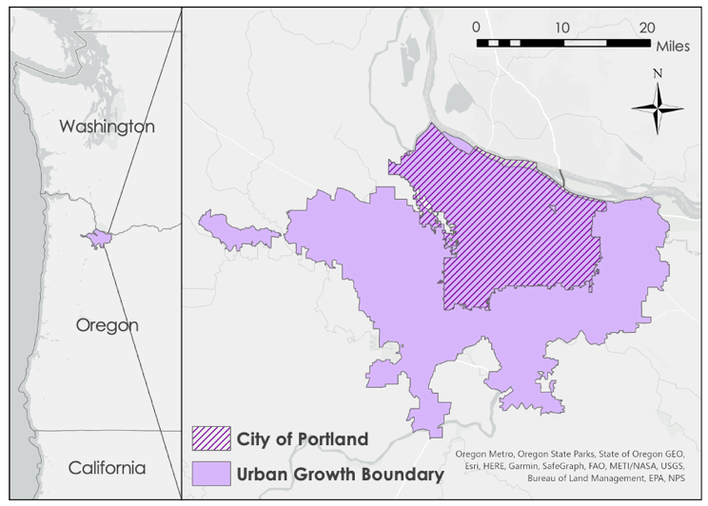
Figure 1. Study area map showing the Portland, Oregon Urban Growth Boundary with inset map.

Martiello & Giacchi (2010) predicted increases in climate change-induced heat wave intensity, frequency, and duration. Extreme heat is of particular concern in cities due to urban heat island (UHI) effect, where urban landscapes experience higher air temperatures relative to surrounding rural or wildland areas. Four primary factors drive UHIs’ elevated temperatures: (1) dense and dark paving/building materials, (2) building density and proximity, (3) reduced vegetation, and (4) waste heat from anthropogenic sources (Larsen, 2015). In the United States, the UHI effect results in typical daytime urban temperatures that are 1° – 7°F and nighttime temperatures that are 2°– 5°F higher than surrounding non-urban landscapes (Hibbard et al., 2017).

As an environmental injustice, Portland’s legacies of racial exclusion are connected to contemporary urban heat issues. Beginning as early as 1844, “Oregon Black exclusion laws” prohibited Black populations from moving to Oregon (Platt & Cray, 2019). In the 1930s, housing discrimination in the form of redlining engendered systematic racial segregation. The Portland zoning code included 15 ‘Zone I’ areas, indicating ‘highest quality’ neighborhoods and restricted them to single-family homes. Simultaneously, redlining allowed private developers to deny sale of properties to minorities, namely Black, Japanese, or Chinese residents (Hughes, 2019). As a result, minority homeownership was geographically restricted (Gibson, 2008). Furthermore, in the 1960s through 1980s, urban renewal plans led to displacement of minority populations in the name of new transit and infrastructural development (Kolmes, 2022).

Currently, Portland faces rapid gentrification and high population density due to the city’s Urban Growth Boundary planning policy, which raises property values and displaces residents in the urban core (O’Toole, 2007). Low-income and communities of color in Portland are disproportionately exposed to the effects of climate change and, in this case, extreme heat. These populations are more likely to live in areas with less tree canopy cover, more pavement, and less access to air conditioning or community shelters (Oregon Metro, n.d.).

Many urban heat studies focused on the Portland, Oregon region offer heat distribution maps through satellite-based land surface temperature (LST), air, and in-situ measurements (Shandas et al., 2019; Antonopoulos et al., 2019; Voelkel et al., 2018). Further, some studies consider socio-demographic factors to understand lived experiences and disproportionate exposure to heat. For example, Voelkel et al. (2018) investigated the connection between specific populations and urban heat in Portland. They found that there is environmental injustice toward marginalized communities, namely non-white and low-income, who are at highest risk of heat exposure and have less adaptive capacity in response to heat (Voelkel et al., 2018). Additionally, Hoffman et al. (2020) offer a critical spatial analysis of intra-urban heat through an environmental justice lens to understand the role of historic redlining in exacerbating heat exposure for Portland’s communities of color. This study found that racially segregated areas in Portland experience up to a 7.1◦C increase in heat compared to other parts of the city (Hoffman et al., 2019). While studies have demonstrated a clear link between historic disinvestment, disenfranchisement, oppression, and heat exposure, there remain gaps in the current literature regarding the experiences of urban heat in Portland. Given this, rather than merely identifying the areas that disproportionately experience heat, our project sought a holistic and fine scale understanding of heat in Portland.

2.2 Project Partners & Objectives
Our DEVELOP team partnered with Depave, a nonprofit organization based in Portland, Oregon. Depave empowers diverse communities by transforming paved areas into vibrant greenspaces and promoting social equity while addressing climate change. This is important because impervious surfaces like concrete and asphalt can exacerbate UHIs. Through teamwork and civic engagement, they create lasting change by removing pavement, reducing excess heat and stormwater pollution, restoring habitats, and fostering stronger human-nature relations (Depave, n.d.).

As Depave was interested in acquiring quantitative data to support their work, we developed an urban heat map using Landsat 8 Thermal Infrared Sensor (TIRS) to capture Land Surface Temperature (LST) and a heat vulnerability map. These maps demonstrated the unequal distribution of excess heat exposure across the city, assessing data from 2018 to 2022 with a focus on June through August. Additionally, to quantify and convey Depave’s role in reducing urban heat, we observed temperature changes in specific case studies of past Depave projects from 2013 to 2022 with focus on June through August.

3. Methodology
3.1 Data Acquisition
3.1.1 Earth Observations
Our team utilized Landsat 8 TIRS Band 10, Level 2, Collection 2, Tier 1 data called directly into Google Earth Engine (GEE). The raw data have a spatial resolution of 100 m that was resampled in GEE with a 30 m grid. We selected images from June through August in 2018 to 2022. The same raw data was used for our case studies, but for an extended period, starting in 2013 and ending in 2022.

3.1.2 Ancillary Data
Alongside the satellite data, we used ancillary datasets to analyze Portland’s UHI from an environmental justice perspective and conduct case studies of Depave sites (Appendix A). First, we used shapefile data of project site footprints provided by Depave for our case study analysis. Then, we downloaded 2020 Census Tract Boundaries, the Urban Growth Boundary, and Portland City Boundary from Oregon Metro’s Regional Land Information System (RLIS). For our social vulnerability analysis, we obtained socioeconomic and housing data from the 2021 American Community Survey 5-Year Estimates and 2020 Decennial Census at the tract level from the TidyCensus package in RStudio. We also collected health data from CDC PLACES at the census tract level and transit and greenspace data from RLIS. Lastly, we downloaded the 1938 Home Owners Loan Corporation (HOLC) Redlining Boundary shapefile from Mapping Inequality.

3.2 Data Processing
3.2.1 Earth Observations
To prepare for our baseline LST analysis, we called in Landsat 8 TIRS imagery using GEE. We filtered for images covering the Portland, Oregon region from June through August in the years 2018 through 2022 and masked cloud and cloud shadow pixels. Additionally, as we used Collection 2 data, we applied the required scale factors to the optical (Equation 1) and thermal bands (Equation 2). Lastly, we converted the thermal band’s unit of degrees from Kelvin to Fahrenheit.

$$Optical band ×0.0000275-0.2$$
(1)
$$Thermal band ×0.00341802+149.0$$
(2)
3.2.2 Social Vulnerability Analysis
For the environmental justice component of our project, the team developed a social vulnerability index. The team worked alongside Joe Gordon at Oregon Metro to develop a new heat-specific index. Using his base R code from the general Social Vulnerability Explorer he developed for Portland, we were able to clean data and prepare for analysis. To select variables for the new index, the team chose 19 heat-specific indicators and processed the data in RStudio Version 2023.06.0+421 (Appendix B). We calculated each variable to be a percent of the total population of each census tract in order to prepare for analysis.

In RStudio, we imported 2021 American Community Survey data, 2020 Decennial Census data, and CDC PLACES data at the tract level. The CDC PLACES data were collected using the 2010 census tracts and were reallocated to the 2020 tracts using the distribution of single and multi-family housing units derived from tax lot data. Then, we imported Oregon Metro RLIS transit and greenspace data. We used a 0.25-mile buffer around transit and greenspace points to calculate the percentage of each census tract that did not fall within the buffers.

3.2.3 Case Study Site Selection
For our case studies, we selected sites using two criteria bins: (1) depaved sites equal to or larger than 5,000 ft² executed from 2016 to 2019 and (2) depaved sites equal to or larger than 10,000 ft² (Table 1). With these bins, we selected 10 sites for our analysis (Figure 2). Additionally, we uploaded the shapefiles provided by Depave into QGIS to clean and digitize points and footprints for these selected sites. Lastly, we exported new shapefiles to prepare for analysis.

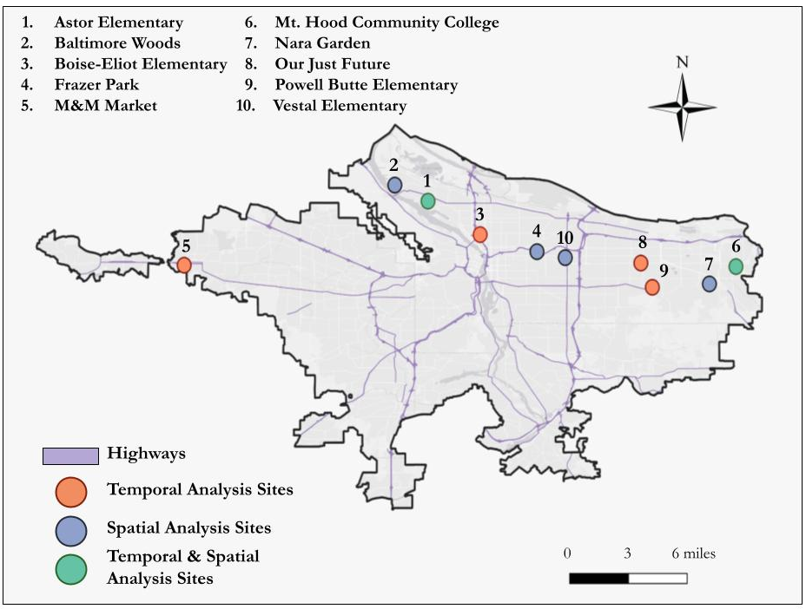
Figure 2. Location of 10 Depave sites selected for case study analysis.
Table 1
Depave sites selected for case study analysis.
Site Name | Year | Size (ft²) | Criteria Bins
 |  |  | Bin 1:  ≥ 5,000 ft² (2016-2019) | Bin 2:  ≥ 10,000 ft²
Astor Elementary (1) | 2016 | 16000 | x | x
Baltimore Woods (2) | 2012 | 64386 |  | x
Boise-Eliot Elementary (3) | 2018 | 8830 | x
Frazer Park (4) | 2011 | 10000 |  | x
M&M Market (5) | 2017 | 5000 | x
Mt. Hood Community College (6) | 2018 | 10150 | x | x
Nara Garden (7) | 2022 | 10000 |  | x
Our Just Future (8) | 2016 | 6000 | x
Powell Butte Elementary (9) | 2019 | 7400 | x
Vestal Elementary (10) | 2009 | 30600 |  | x

3.3 Data Analysis
3.3.1 Land Surface Temperature (LST) Urban Heat Map
For our LST, we took our processed and cleaned Landsat 8 TIRS image collection with a script provided by Dr. Kent Ross. The script was modified by our team in GEE to calculate the median LST at each pixel. We clipped this median LST data to our study area to serve as our baseline five-year LST map. We then exported the image as a GeoTIFF file. Lastly, we loaded the raster image and a shapefile of the study area’s census tracts into ArcGIS Pro. Using zonal statistics, we calculated the mean LST by census tract and mapped these values.

3.3.2 Social Vulnerability Analysis
For our Social Vulnerability Index (SVI), we used Principal Component Analysis (PCA) in RStudio. After gathering all 19 indicators, our team ran the PCA to test for excessive collinearity of variables and generate components. We removed indicators with a correlation value above 0.9, therefore we removed “percent of multifamily homes” because it strongly correlated with “percent of renters.” We also removed transit and greenspace data, because the former inversely correlated with “no personal vehicle,” and the latter was heavily influenced by greenspace in the Urban Growth Boundary. Then, we calculated eigenvalues, or the scores, of the different components generated by the PCA. We identified four significant components that had an eigenvalue of greater than 1. Next, in a stepwise fashion, we removed indicators that correlate with subcomponents with correlation less than 0.5 absolute correlation. Namely, we removed both “percent unemployed” and “percent without tree canopy” as these did not correlate with any of the significant components. Then, we confirmed that the significant components accounted for more than 70% of the data variation, which was 79.9%, and calculated the scores of the final significant components (Appendix B). Finally, we summed the equally weighted scores of the subcomponents to calculate our final social vulnerability score.

After completing the SVI, our team joined both the individual subcomponent scores and the final SVI scores to the 2020 Census Tract shapefiles. We visualized the geographic distribution in ArcGIS Pro Version 3.1. Then, we joined the mean LST values and the SVI score to create a bivariate map displaying areas with an overlap of high surface temperatures and high social vulnerability scores.

3.3.3 Case Study Analysis
Our case study analysis consisted of a temporal analysis with sites from Bin 1 (≥5,000 ft², 2016–2019) and a spatial analysis with sites from Bin 2 (≥10,000 ft²), all performed using GEE. The temporal analysis was conducted at six sites, all depaved in the date range of 2016 to 2019 to ensure at least three years of summer data were available before and after the site was completed. With these six sites, we assessed temperatures over the maximum period of data available based upon the minimum time horizon of available data either before or after the project completion year. For instance, if the site was completed in 2019, we created an LST for the years 2016 to 2018 and 2020 to 2022. Then, we compared the before and after mean LST over (1) the site footprint and (2) a 100-ft radial buffer around the site footprint and point location. Given this, we assessed the impact of the depaving intervention on local-scale LST.

For the spatial analysis, we also selected six sites, all with a site footprint of at least 10,000 ft². We used the baseline 5-year LST to calculate the mean temperature of (1) the site footprint and (2) a 100-ft radial buffer around the site footprint and point location. Then, we compared these temperatures to a quarter mile radial buffer around the site footprint and point location. Given this, we assessed how the site LST compared to that of the surrounding region.

4. Results & Discussion
4.1 Analysis of Results
4.1.1 Land Surface Temperature (LST) Urban Heat Map
For our baseline 5-year LST, the hottest areas are indicated in red, and the coolest areas are in blue and white (Figure 3). Figure 4 shows the mean of these pixel values per census tract, with the hottest census tracts in dark red and the coolest in white. The hottest areas appear in the city’s peripherals, particularly in the east and far west of the Urban Growth Boundary (Figure 4). These findings are consistent with our expectations based on the UHI effect and environmental justice issues in Portland. Meanwhile, the coolest area is Forest Park in Northwest Portland, a large 5,200-acre protected area of continuous forest canopy (Figure 4).
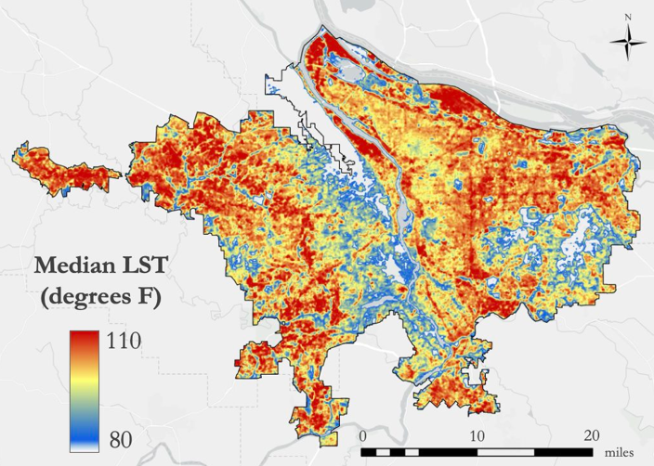
Figure 3. Baseline LST map for Portland, Oregon from 2018 to 2022 using Landsat TIRS imagery.

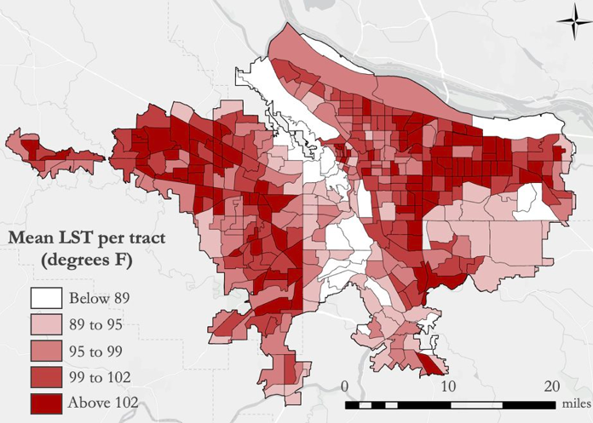
Figure 4. Mean LST, from 2018 to 2022, by census tract for Portland, Oregon.

4.1.2 Social Vulnerability Index
Our PCA generated four principal subcomponents, or categories of indicators: racial demographics, socioeconomic profiles, housing characteristics, and aging and health disparities (Figure 5). The PCA identified correlated variables, which we used to visualize the intersectionality of heat vulnerability indicators. The compounding effects of these vulnerability indicators are influenced by historic disenfranchisement and continuing injustices. The PCA Loading table heat map, which shows correlation values of each variable, can be found in Appendix B.

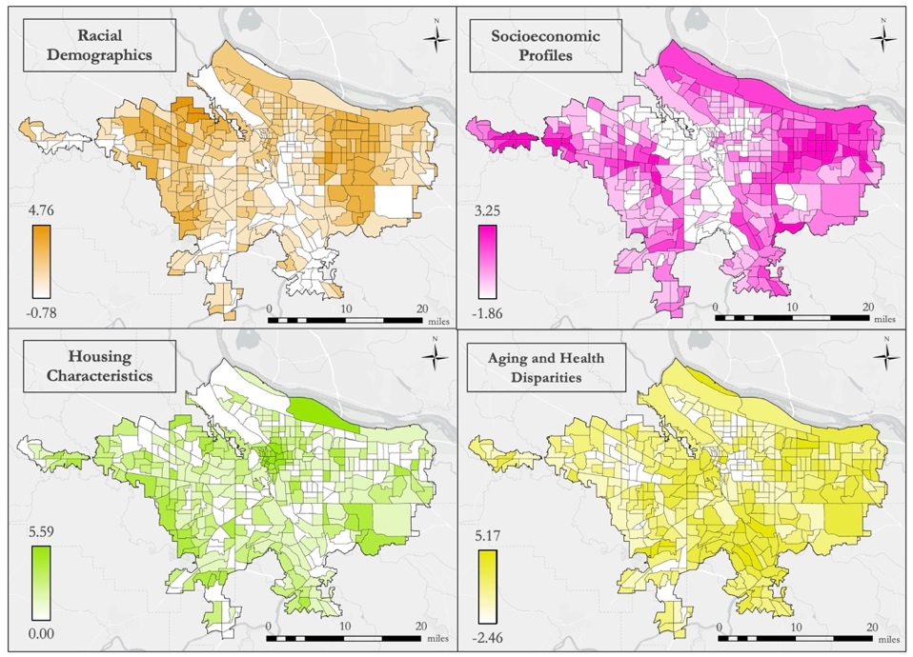
Figure 5. PCA Subcomponent scores visualized throughout Portland, Oregon. For each map, more saturated colors correspond to higher relative potential vulnerability. From top left to bottom right, we have racial demographics, socioeconomic profiles, housing characteristics, and aging and health disparities.

Based on our PCA, census tracts were visualized with higher potential social vulnerability in dark blue and lower potential social vulnerability in white (Figure 5). Areas in the urban core appear to have a lower potential social vulnerability in relation to our final sociodemographic indicators. Meanwhile, the census tracts in East Portland appear to experience a higher potential social vulnerability.

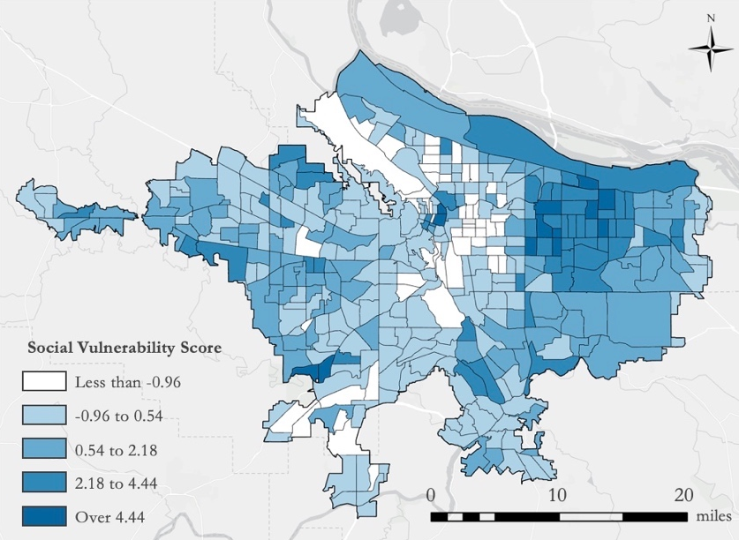
Figure 6. Social Vulnerability by census tract map for Portland, Oregon.

Combining this SVI with our analysis of LST by census tract, we identified Portland’s frontline communities (Figure 7). The vertical axis is the social vulnerability variable, with lower vulnerability to higher vulnerability in white to blue. The horizontal axis is the LST variable, with lower temperatures to hotter temperatures in white to red. The lightest areas of the map indicate communities that have lower potential vulnerability and experience less heat. Conversely, the dark purple highlights areas that have higher potential heat vulnerability and experience extreme heat. These communities at the intersection of high vulnerability and high heat are Portland’s frontline communities of the urban heat crisis. Frontline communities are under-resourced and historically disenfranchised groups bearing the brunt of climate change injustice. These communities are fighting to mitigate and adapt to these environmental burdens.

In conversation with Depave, we decided to use the term “frontline community” to appropriately describe the areas with the highest potential vulnerability to extreme heat in Portland. It was critical for us to be intentional with the language we used to represent these communities, understanding that the label “vulnerability” can have a negative and victimizing connotation. However, we also recognize that “Social Vulnerability Index” is an established tool in urban heat literature. Given this, we continued the use of “vulnerability” as a tool and metric but refrained from using it as a label for these communities.

Additionally, Figure 7 illustrates how disenfranchisement and contemporary environmental injustices manifest in spatial patterns across the city. Historic redlining continues to impact contemporary experiences, with previously redlined areas tending to have denser urban buildup and less greenspace. On the other hand, we found that neighborhoods rated as “green” in the 1938 HOLC policy experience a land surface temperature average of 14ºF cooler than historically redlined areas (Appendix C). Merely following the patterns of historic redlining, however, does not tell the full story. Gentrification is changing neighborhood compositions throughout Portland. It displaces low-income and Black, Indigenous and People of Color (BIPOC) communities from the urban core and into the peripherals of the city that often experience disinvestment, over-pavement, and a lack of greenspace, contributing to these communities’ disproportionate exposure to extreme heat. Given these environmental justice issues, Depave’s efforts in mitigating urban heat are significant for increasing access to greenspace and empowering frontline communities who are disproportionately burdened by environmental injustices.

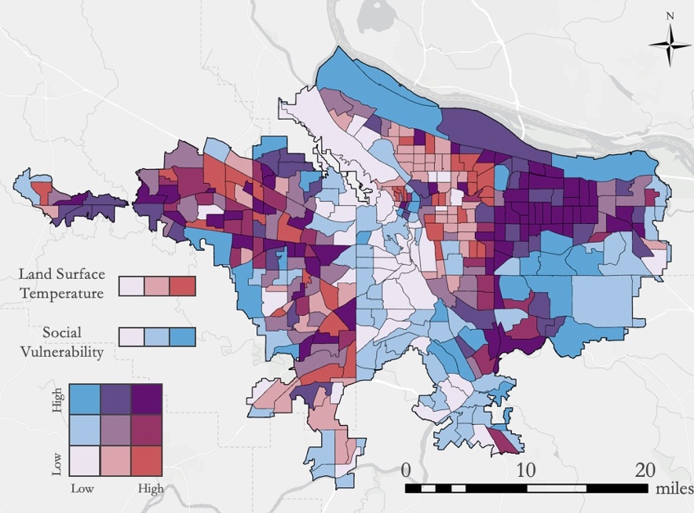
Figure 7. Bivariate social vulnerability and urban heat map for Portland, Oregon.

4.1.3 Case Study Analysis
In our case study temporal analysis, four out of the six sites exhibited decreases in mean LST after depaving. Table 2 depicts the years included in our land surface temperature (LST) data analysis, showing the raw temperature change as the difference in mean LST within the site footprint, and the normalized temperature change relative to difference in mean LST of the site footprint in relation to the mean land surface temperature of the entire city. Four out of six sites demonstrated an average decrease in LST for an average decrease in LST of nearly 1ºF across all six sites. The largest change in mean LST occurred at Powell Butte Elementary (Figure 8), with over 7ºF decrease in average LST after normalization.

Table 2
Temporal comparison of case study differences in LST from the Portland mean LST across selected Depave sites.
Site (Yr) | Size (ft²) | Before (Yr) | After (Yr) | Change (ºF) | Change after Normalization (ºF)
Astor Elementary (2016) | 16000 | 2013–2015 | 2017–2019 | +2.9 | +4.2
Boise-Eliot Elementary (2018) | 8830 | 2014–2017 | 2019–2022 | -2.2 | -2.4
M&M Market (2017) | 5000 | 2013–2016 | 2018–2021 | -2.4 | -0.8
Mt. Hood Community College (2018) | 10150 | 2014–2017 | 2019–2022 | +1.8 | +1.7
Our Just Future (2016) | 6000 | 2013–2015 | 2017–2019 | -5.0 | -0.9
Powell Butte Elementary (2019) | 7400 | 2016–2018 | 2020–2022 | -2.0 | -7.7

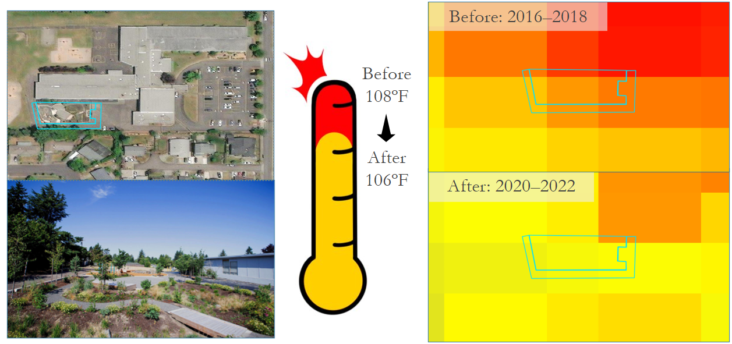Figure 8. Case study for Powell Butte Elementary depaving project in 2019 including site aerial images, and before and after LST maps using Landsat 8 TIRS data.

However, our spatial analysis did not reveal an impact of community depaving, with most sites and 100 ft site buffers exhibiting a higher mean LST than the surrounding region of quarter-mile radius. We hypothesized that this could be because Depave often selects sites in densely paved regions, so even after depaving, the Landsat 8 TIRS pixels over these sites tend to exhibit higher LST with more surrounding pavement. For this reason, we believe that the temporal assessment more accurately captures the impacts of Depave’s efforts. One site that was large enough to show an impact was the Baltimore Woods site, which consisted of nearly 2 acres of concrete removal. Comprehensive results of our spatial analysis can be found in Appendix D.

4.2 Study Limitations
A large limitation to our project was the spatial and temporal resolution of the Landsat 8 TIRS data. For one, the raw TIRS imagery is taken at 100m resolution and resampled in GEE to 30m pixels. As the majority of Depave sites make up only a portion of a Landsat 8 TIRS pixel, it is difficult to accurately capture and evaluate the site impacts to LST. Second, Depave has been in operation since 2008. However, Landsat 8 was launched in 2013, limiting the selection pool for case study sites and eliminating more mature and grown-in sites.

Our social vulnerability analysis was also limited by the data available. Our team wanted to include heat-related data, such as access to at-home air conditioning or public cooling centers, that would have made our heat vulnerability index more comprehensive of lived heat experiences. Additionally, census tract-level data cannot adequately explain neighborhood-level experiences and often does not capture the whole story of a community’s experiences. There was a general lack of direct communication and involvement with the communities that we were studying, which could have helped to better capture these neighborhood-level experiences and patterns. A comprehensive social vulnerability analysis requires community participation to appropriately represent these communities and identify the processes that most contribute to vulnerability. However, given the time restrictions and limited bandwidth of our team, we were unable to gather necessary quantitative and qualitative data.

4.3 Future Work
To address our project’s limitations, it is important to integrate fine-scale and in-situ data with remote sensing to validate and improve the resolution of our LST and case study analyses. Remote sensing data offer an exciting opportunity to focus on multi-scalar research that highlights how individual experiences are connected to and shaped by world processes. Further, adopting a mixed methods approach is critical for understanding communities’ urban heat experiences. With more community engagement, future work can incorporate qualitative and quantitative data that are not easily measured or publicly available. Though one is not planned, a second term Portland urban heat project that uses more ethnographic methods to focus on experiential and qualitative data could build upon our work. By surveying usership of sites and calculating spatial patterns of access to and distance from greenspace and cooling resources using remote sensing and in-situ data, a second term project could capture how local initiatives reducing urban heat address environmental justice issues and impact neighborhood-level temperature change.

Lastly, future DEVELOP projects can work to incorporate communities in our research process and adopt intentional methodologies. When working with and representing communities, it is crucial to reflect upon and be intentional with our language. For example, our project spoke with Depave and found that “frontline communities” was a more appropriate descriptor than labeling communities as “vulnerable.” Further, it is crucial to recognize our positionality as researchers working in communities of which we are most likely not a member. In this circumstance, we must ensure that our research prioritizes the community we are working with, and we continuously reflect upon the purpose and use of our work throughout the project. With this, DEVELOP can foster a more inclusive scientific community with long-lasting relationships and support community capacity- and resilience-building. The VEJ node, in particular, has the opportunity to demonstrate the importance and feasibility of adopting these principles and methods.

5. Conclusions
Using NASA Earth observations, our project demonstrated the significance of Depave’s efforts in mitigating local urban heat. Our LST and SVI analyses confirmed that heat is experienced unequally across Portland, based on the physical environment and compounding sociodemographic factors. In particular, we identified Portland’s frontline communities experiencing high potential social vulnerability to extreme temperatures due to environmental injustices and over-pavement. By highlighting these communities adapting to and combating urban heat, we further illustrated how important Depave is for not only reducing local heat, but also for empowering and supporting under-resourced and historically disenfranchised communities.

Additionally, our case study analysis revealed that Depave’s impact on urban heat is observable and quantifiable using remote-sensing data and geospatial tools. Across the six sites in our temporal analysis, we observed an average of 1ºF decrease and a maximum of 7.7ºF decrease after normalization. As these greenspaces continue to mature, we hypothesize that their cooling effect will increase. However, to better examine Depave’s impact, it is necessary to incorporate qualitative data and increase community engagement.

Overall, our project provided Depave with quantitative backing for communicating the impact of their work on local-scale heat mitigation. Qualitative and higher resolution quantitative data would more accurately capture Depave's important work. Yet, our project served as a launching point for increased engagement with community organizations, such as Depave, to address urban heat and local initiatives against environmental injustices. With this data, Depave can supplement their storytelling to inspire people to get involved in local efforts of urban regreening and climate justice.

6. Acknowledgements
We would like to acknowledge and thank the following mentors, partners, and collaborators in their support of our project. Thank you to our node lead, Julianne Liu, for her leadership and project support. Thank you to Depave, particularly Katya Reyna and Katherine Rose, for their continued partnership and important local impact in the City of Portland. Thank you to our science advisors Dr. David Hondula (Arizona State University), Lance Watkins (Arizona State University), Joe Gordon (Oregon Metro, Portland Community College), Joshua Applegate (Oregon State University), Lauren Childs-Gleason (NASA Langley Research Center), Dr. Kenton Ross (NASA Langley Research Center), and Dr. Vivek Shandas (Portland State University) for their continued support and guidance throughout our project.

Any opinions, findings, and conclusions or recommendations expressed in this material are those of the authors and do not necessarily reflect the views of the National Aeronautics and Space Administration. This material is based upon work supported by NASA through contract NNL16AA05C.

7. Glossary
Depaving – the practice of removing impervious surfaces, such as parking lot pavement, and replacing it with pervious surfaces.
Disenfranchisement – The state of being deprived of a right or privilege afforded to others, particularly in the case of access to resources for minority groups.
Earth observations – Satellites and sensors that collect information about the Earth’s physical, chemical, and biological systems over space and time.
Eigenvalue – An absolute value integer that represents the total amount of variance within a given principal component.
Environmental injustice – The disproportionate impact of environmental hazards on marginalized communities, driven by systemic barriers, historic disenfranchisement, and colonial legacies.
Environmental justice – According to the United States Environmental Protection Agency, the fair and meaningful treatment of all people, with respect to the development, implementation, and enforcement of environmental laws, regulations, and policies.
Frontline community – Under-resourced and historically disenfranchised groups bearing the brunt of climate change injustices and fighting to mitigate and adapt to such environmental burdens.
Google Earth Engine (GEE) – A cloud-based geospatial analysis platform that allows users to visualize and analyze satellite imagery.
In-situ – Meaning “in the original location,” this data is collected adjacent to the measuring instrument, such as temperature measurements from a thermometer.
Land Surface Temperature (LST) – A measurement of how hot the ground is, which is different than air temperature.
Principal Component Analysis (PCA) – A technique used to reduce the dimensionality of large data sets, by transforming a large set of variables into a smaller one that still contains most of the information in the large set to increase interpretability.
Regional Land Information System (RLIS) – A system by Oregon Metro that compiles more than 150 publicly available GIS data layers, such as Census and sociodemographic data, to serve as the spatial data infrastructure for the Portland metropolitan area.
Remote sensing – The process of detecting and monitoring physical characteristics of an area by measuring its reflected or emitted radiation at a distance, typically from a satellite or aircraft.
Social Vulnerability Index (SVI) – A spatial analysis that calculates the vulnerability score for a defined region based on various indicators to help local officials identify communities that may need support.
Urban heat island (UHI) – Phenomenon where a city experiences hotter temperatures than surrounding rural areas since urban areas have more dark, impervious surfaces, such as asphalt, steel, and brick, that absorb wavelengths of energy from the sun and produce heat, whereas rural areas have tree canopy and water bodies that provide cooling.
Vulnerability – The social, environmental, economic, and political factors and circumstances of a community or system that make it susceptible to the damaging effects of a hazard.
Zonal statistics – A spatial analysis that calculates statistics on cell values of a raster (a value raster) within the zones defined by another dataset.

8. References
Antonopoulos, C., Trusty, A., & Shandas, V. (2019). The role of building characteristics, demographics, and urban heat islands in shaping residential energy use. City and Environment Interactions, 3. https://doi.org/10.1016/j.cacint.2020.100021.
Cusick, D. (2020). Chicago Learned Climate Lessons from Its Deadly 1995 Heat Wave. Scientific American. Retrieved June 16, 2023, from https://www.scientificamerican.com/article/chicago-learned-climate-lessons-from-its-deadly-1995-heat-wave1/
Depave. (n.d.) About Us - Mission. Retrieved June 22, 2023, from https://depave.org/about/
Depave (2008). Depave sites [Data set]. Depave. Retrieved June 22, 2023.
Earth Resources and Observation Science Center (2020). USGS EROS Archive - Landsat Archives - Landsat 8-9 OLI/TIRS Collection 2 Level-2 Science Products [Data set]. USGS EROS. Retrieved June 20, 2023 from doi.org/10.5066/P9OGBGM6
Gibson, K. J. (2008). Bleeding Albina: A History of Community Disinvestment, 1940-2000. Transforming Anthropology, 15(1), 3–25. https://doi.org/10.1525/tran.2007.15.1.03
Gronlund, C. J. (2014). Racial and socioeconomic disparities in heat-related health effects and their mechanisms: A review. Current Epidemiology Reports, 1(3), 165–173. https://doi.org/10.1007/s40471-014-0014-4
Hattis, D., Ogneva-Himmelberger, Y., & Ratick, S. (2012). The spatial variability of heat-related mortality in Massachusetts. Applied Geography, 33, 45–52. https://doi.org/10.1016/j.apgeog.2011.07.008
Hibbard, K., Hoffman, F., Huntzinger, D., & West, T. (2017). Changes in land cover and terrestrial biogeochemistry.
Hoffman, J. S., Shandas, V., & Pendleton, N. (2020). The Effects of Historical Housing Policies on Resident Exposure to Intra-Urban Heat: A Study of 108 US Urban Areas. Climate, 8(1), 12. https://doi.org/10.3390/cli8010012.
Hughes, J. (2019). Historical Context of Racist Planning: A History of How Planning Segregated Portland. City of Portland, Oregon Bureau of Planning and Sustainability (BSP).
Kolmes, S. A. (2022). Intended and unintended consequences of two paradigms of urban planning, and their social justice and human health impacts, in Portland, Oregon. Environments, 9(10). https://doi.org/10.3390/environments9100130
Larsen, L. (2015). Urban climate and adaptation strategies. Frontiers in Ecology and the Environment, 13(9), 486–492. https://doi.org/10.1890/150103
Martiello, M. A., & Giacchi, M. V. (2010). High temperatures and health outcomes: A review of the literature. Scandinavian Journal of Public Health, 38(8), 826–837. https://doi.org/10.1177/1403494810377685
Mathew, T. (2017). America’s Most (and Least) Sustainable Cities. Bloomberg.com. Retrieved June 22, 2023, from https://www.bloomberg.com/news/articles/2017-08-10/america-s-most-and-least-sustainable-cities
Multnomah County. (2022). 2021 heat killed 72 people in Multnomah County; most were older, lived alone, had no AC. Retrieved March 15, 2023, from https://www.multco.us/help-when-its-hot/news/2021-heat-killed-72-people-multnomah-county-most-were-older-lived-alone-had
Nelson, M., Winling, L., Marciano, R., Connolly, N., et al. (2020). Mapping Inequality [Data set]. Retrieved July 5, 2023, from https://dsl.richmond.edu/panorama/redlining/
NOAA National Centers for Environmental information (2023). Climate at a glance: City time series [Data set]. NOAA. Retrieved on July 7, 2023 from https://www.ncei.noaa.gov/access/monitoring/climate-at-a-glance/city/time-series
Oregon Metro (n.d.). Equity Climate Environment. Retrieved June 22, 2023, from https://regionalbarometer.oregonmetro.gov/pages/equity-climate-environment
O’Toole, R. (2007). Debunking Portland: The city that doesn’t work. SSRN Electronic Journal. https://doi.org/10.2139/ssrn.1021286
Platt, A. E., & Cray, L. (2019). “Out of order”: Pasting Together the Slavery Debate in the Oregon Constitution. Oregon Historical Quarterly, 120(1), 74–101. https://doi.org/10.5403/oregonhistq.120.1.0074
Robert K. Nelson, LaDale Winling, Richard Marciano, Nathan Connolly, et al., “Mapping Inequality,” American Panorama, ed. Robert K. Nelson and Edward L. Ayers, accessed July 5, 2023, from https://dsl.richmond.edu/panorama/redlining/
Shandas, V., Voelkel, J., Williams, J., & Hoffman, J. (2019). Integrating Satellite and Ground Measurements for Predicting Locations of Extreme Urban Heat. Climate, 7(1), Article 1. https://doi.org/10.3390/cli7010005
Turner, B. L., Kasperson, R. E., Matson, P. A., McCarthy, J. J., Corell, R. W., Christensen, L., Eckley, N., Kasperson, J. X., Luers, A., Martello, M. L., Polsky, C., Pulsipher, A., & Schiller, A. (2003). A framework for vulnerability analysis in sustainability science. Proceedings of the National Academy of Sciences, 100(14), 8074–8079. https://doi.org/10.1073/pnas.1231335100
US Census Bureau QuickFacts: Portland City, Oregon. (2023). Retrieved June 22, 2023, from https://www.census.gov/quickfacts/portlandcityoregon
US Department of Commerce, N. (n.d.). During a Heat Wave. NOAA’s National Weather Service. Retrieved March 15, 2023, from https://www.weather.gov/safety/heat-during
Voelkel, J., Hellman, D. E., Sakuma, R., & Shandas, V. (2018). Assessing Vulnerability to Urban Heat: A Study of Disproportionate Heat Exposure and Access to Refuge by Socio-Demographic Status in Portland, Oregon. International Journal of Environmental Research and Public Health. https://doi.org/10.3390/ijerph15040640

9. Appendices

Appendix A

Table A1.
List of Ancillary Datasets used for this project
Dataset | Date(s) | Description | Purpose | Source
Depave Site Footprint | 2008 – 2023 | Shapefile consisting of Depave site GIS data | Overlay onto LST to depict depaved sites; case studies | Depave
City Time Series | August, 1938 – 2023 | Average temperature data of Portland, Oregon with anomalies based on 1991-2000 period average temperature | Input into R for climate stripes graphic | NOAA
American Community Survey (ACS) 5- Year Estimate Socioeconomic Data | 2020 | Socioeconomic and housing data at census tract level, namely race, income, unemployment, language, education, age, healthcare, multifamily housing, renter occupation, internet, ownership of personal vehicles, and disability status | Input into Principal Component Analysis for vulnerability index | TidyCensus in RStudio
Center for Disease Control (CDC) PLACES Health Data | 2020 | Heath data at census tract level concerning heart disease, asthma, cancer, and health insurance coverage | Input into Principal Component Analysis for vulnerability index | CDC PLACES
US Census Tract Shapefile | 2020 | Shapefile consisting of polygons indicating Portland Census Tracts | LST Map; Vulnerability Index | RLIS Oregon Metro
Portland City Boundary | 2023 | City boundary for Portland | LST Map | RLIS Oregon Metro
Urban Growth Boundary (UBG) | 2023 | Boundary around Portland controlling urban expansion managed by Oregon Metro | LST Map | RLIS Oregon Metro
Home Owners’ Loan Corporation (HOLC) Neighborhood Redlining Grades | 2020 | 1938 Redlining boundaries indicating neighborhood “grade” based on HOLC surveys | Used for analyzing relationship between historic redlining and exposure to heat | Mapping Inequality
Outdoor Recreation and Conservation Areas (ORCA) | 2023 | Outdoor areas used for recreation and conservation including parks, natural areas, golf courses, cemeteries, school land, etc. | Used for calculating access to greenspace per census tract | RLIS Oregon Metro

Appendix B

Table B1
Indicators used in Social Vulnerability Index
Indicator | Source | Year | Table
Population over 25 without high school diploma | American Community Survey | 2021 | B06009
Households without access to personal vehicle | American Community Survey | 2021 | B08201
Population with a disability | American Community Survey | 2021 | B18135
Population without health insurance coverage | American Community Survey | 2021 | B18135
Population that is unemployed | American Community Survey | 2021 | B23025
Housing units occupied by multiple families | American Community Survey | 2021 | B23024
Housing units with internet subscriptions | American Community Survey | 2021 | B28002
Population with limited English proficiency | American Community Survey | 2021 | C16001
Population under 200% poverty level (low income) | American Community Survey | 2021 | C17002
Population under age 5 | Decennial Census | 2020 | DP1
Population over age 64 | Decennial Census | 2020 | DP1
BIPOC population | Decennial Census | 2020 | DP1
Population that rent | Decennial Census | 2020 | DP1
Population with asthma | CDC PLACES | 2022 | N/A
Population with cancer | CDC PLACES | 2022 | N/A
Population with heart disease | CDC PLACES | 2022 | N/A
Population with Chronic obstructive pulmonary disease (COPD) | CDC PLACES | 2022 | N/A
Population with access to transportation | Oregon Metro RLIS | 2023 | N/A
Population with access to greenspace | Oregon Metro RLIS | 2023 | N/A

Table B2
PCA Loading Values for each subcomponent with blue indicating positive correlation and red indicating negative correlation
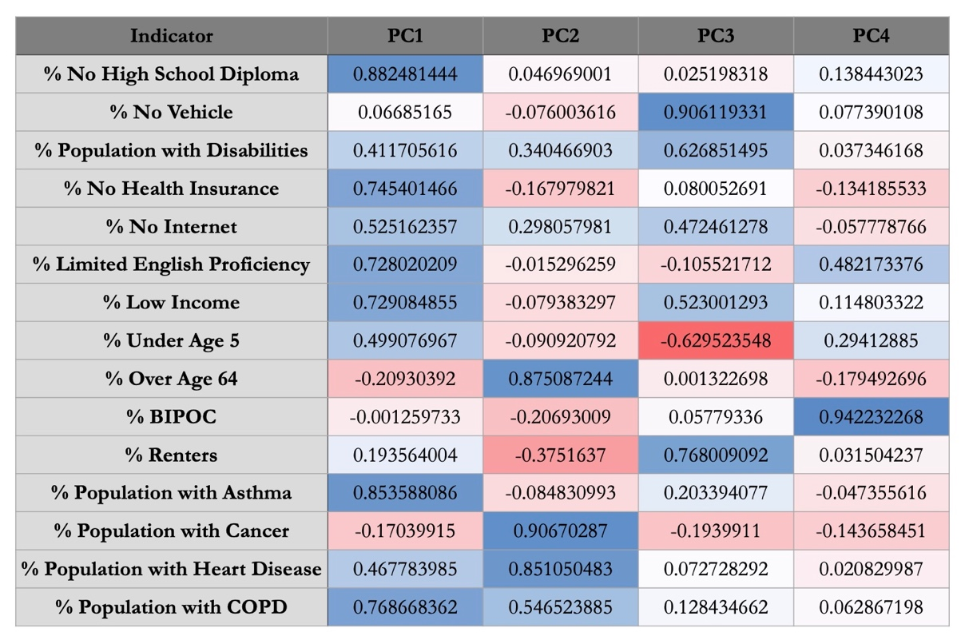

Appendix C

Figure C1. Map showing the City of Portland with 1938 HOLC Redlining Grades.

Figure C2. Boxplot showing distribution of mean LST in each category of 1938 HOLC redlining grade.

Appendix D

Table D1
Case study spatial analysis results of comparisons between on-site and surrounding areas of 0.25-mile buffer mean LST
Site (Yr) | Size (ft²) | LST (Yr) | Site (ºF) | Buffer (ºF) | Difference (ºF)
Astor Elementary | 16,000 | 2018–2022 | 106.8 | 100.8 | 6.0
Baltimore Woods | 64,386 | 2018–2022 | 98.5 | 103.1 | -4.5
Frazer Park | 10,000 | 2018–2022 | 101.3 | 101.2 | 0.2
Mt. Hood Community College | 10,150 | 2018–2022 | 100.5 | 100.9 | -0.4
Nara Garden | 10,000 | 2018–2022 | 104.2 | 103.3 | 0.9
Vestal Elementary | 36,000 | 2018–2022 | 102.7 | 101.6 | 1.0

